Sprawozdanie

Lab. 4

# Zadanie 1

## X = ∑ [1,3,11,12,13,14,15],

|  |  |  |  |  |
| --- | --- | --- | --- | --- |
| AB/CD | 00 | 01 | 11 | 10 |
| 00 | 0 | 1 | 1 | 0 |
| 01 | 0 | 0 | 0 | 0 |
| 11 | 1 | 1 | 1 | 1 |
| 10 | 0 | 0 | 1 | 0 |

AB +ACD +!A!BD

## Y = ∑ [0,1,2,3,7,12,14],

|  |  |  |  |  |
| --- | --- | --- | --- | --- |
| AB/CD | 00 | 01 | 11 | 10 |
| 00 | 1 | 1 | 1 | 1 |
| 01 | 0 | 0 | 1 | 0 |
| 11 | 1 | 0 | 0 | 1 |
| 10 | 0 | 0 | 0 | 0 |

!A!B+!ACD+AB!D

## Z = ∑ [0,2,3,7,11,13,15]

|  |  |  |  |  |
| --- | --- | --- | --- | --- |
| AB/CD | 00 | 01 | 11 | 10 |
| 00 | 1 | 0 | 1 | 1 |
| 01 | 0 | 0 | 1 | 0 |
| 11 | 0 | 1 | 1 | 0 |
| 10 | 0 | 0 | 1 | 0 |

CD+ABD+!A!B!D

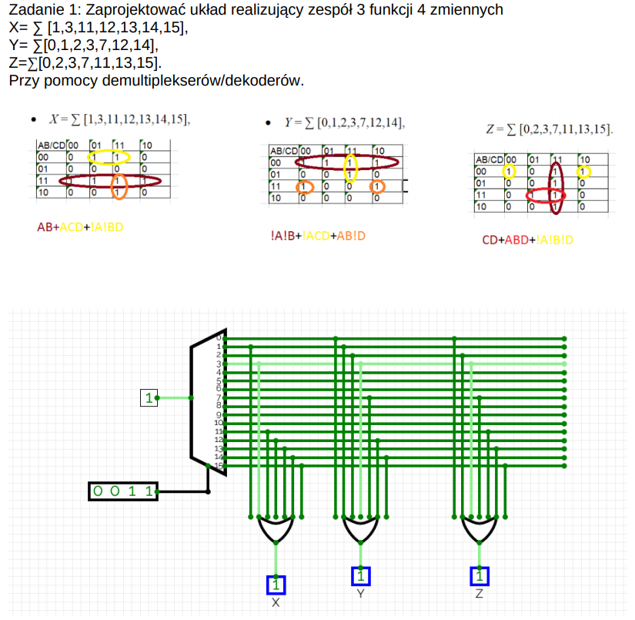

# Zadanie 2

Y = ∑[0,1,2,6,8,10,11,12;(4,14)]

|  |  |  |  |  |
| --- | --- | --- | --- | --- |
| AB/CD | 00 | 01 | 11 | 10 |
| 00 | 1 | 1 | 0 | 1 |
| 01 | - | 0 | 0 | 1 |
| 11 | 1 | 0 | 0 | - |
| 10 | 1 | 0 | 1 | 1 |

|  |  |  |  |  |  |  |  |
| --- | --- | --- | --- | --- | --- | --- | --- |
|  | A | B | C |  | 0 | 1 |  |
| ABC | 0 | 0 | 0 |  | 1 | 1 | 1 |
| ABC | 0 | 0 | 1 |  | 1 | 0 | !D |
| ABC | 0 | 1 | 0 |  | - | 0 | 0 |
| ABC | 0 | 1 | 1 |  | 1 | 0 | !D |
| ABC | 1 | 0 | 0 |  | 1 | 0 | !D |
| ABC | 1 | 0 | 1 |  | 1 | 1 | 1 |
| ABC | 1 | 1 | 0 |  | 1 | 0 | !D |
| ABC | 1 | 1 | 1 |  | - | 0 | 0 |

!D+!A!B!C+A!BC

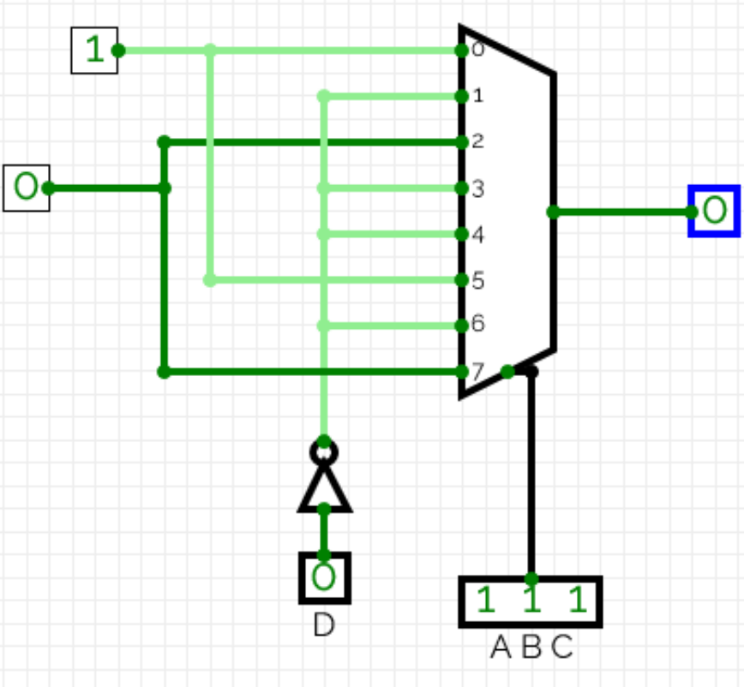

# Zadanie 3

Y = ∑[0,2,4,9,11,13,16,17,20,21,27,31;(3,6,10,15,18,22,25,28,29)]

|  |  |  |  |  |  |  |  |  |
| --- | --- | --- | --- | --- | --- | --- | --- | --- |
| AB/CDD | 000 | 001 | 011 | 010 | 110 | 111 | 101 | 100 |
| 00 | 1 | 0 | - | 1 | - | 0 | 0 | 1 |
| 01 | 0 | 1 | 1 | - | 0 | - | 1 | 0 |
| 11 | 0 | - | 1 | 0 | 0 | 1 | - | - |
| 10 | 1 | 1 | 0 | - | - | 0 | 1 | 1 |

|  |  |  |  |  |  |  |  |  |  |
| --- | --- | --- | --- | --- | --- | --- | --- | --- | --- |
|  | A | B | E |  | 00 | 01 | 11 | 10 | U |
| ABE | 0 | 0 | 0 |  | 1 | 1 | - | 1 | 1 |
| ABE | 0 | 0 | 1 |  | 0 | - | 0 | 0 | 0 |
| ABE | 0 | 1 | 0 |  | 0 | - | 0 | 0 | 0 |
| ABE | 0 | 1 | 1 |  | 1 | 1 | - | 1 | 1 |
| ABE | 1 | 0 | 0 |  | 1 | - | - | 1 | 1 |
| ABE | 1 | 0 | 1 |  | 1 | 0 | 0 | 1 | !D |
| ABE | 1 | 1 | 0 |  | 0 | 0 | 0 | - | 0 |
| ABE | 1 | 1 | 1 |  | - | 1 | 1 | - | 1 |

